OPERATION & MAINTENANCE MANUAL FOR HIGH SPEED DOOR

CLIENT: CONGLOMERATE
PROJECT: CONGLOMERATE
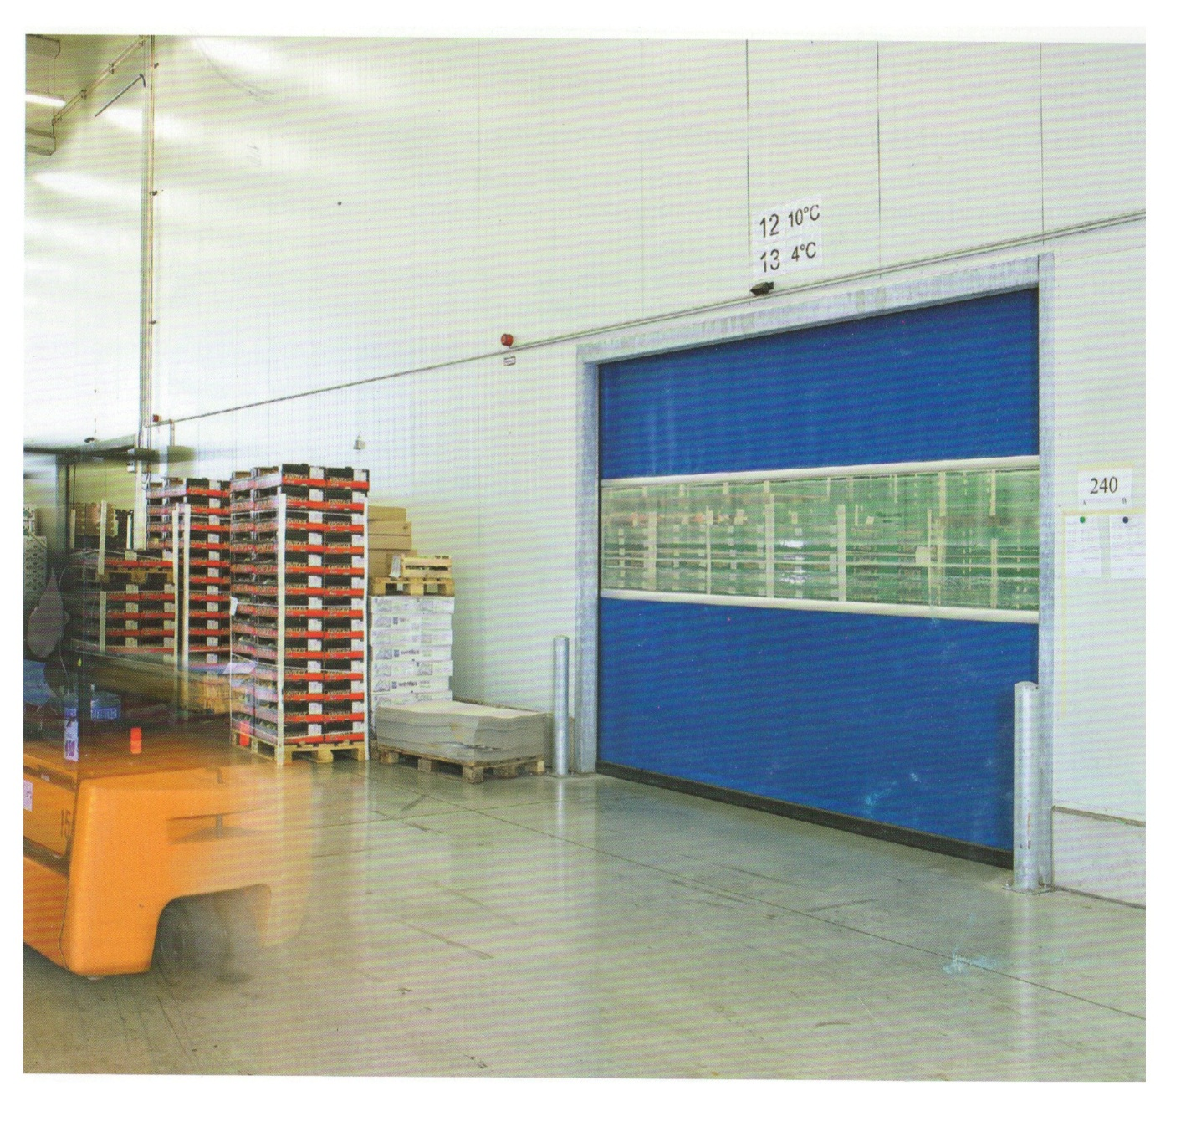
MFG.YEAR: 2021

DESIGNED, DEVELOPED & MARKETED BY



Address- G-BLOCK, 1ST FLOOR, THERMAX CHOWK MIDC, ABOVE RENAULT SHOWROOM CHINCHWAD, PUNE-411019
TEL.NO: - +912066304033
EMAIL: -info@nihva.com

www.nihva.com

PRODUCT - HIGH SPEED DOOR
PRODUCT SIZE | 3415 mm (CW) X 4300 mm (CH)
PO NO | PUNE/CP/053/20-21/R1
PREPARED BY | SIDDHESHWAR SHELAKE
DATE | 25.01.2021

DESPATCH & UNLOADING

- Loading, for dispatch, will be our responsibility. On receipt of the High speed door at site, please check and ensure that there is no physical damage to the equipment.

- While unloading the equipment from the transporting vehicle, please ensure to use slings with rated capacity higher than the gross weight of the Stationary lift in packed condition.

ORDERING OF SPARES

  - When ordering for spare, please specify the following in your Purchase Order.

    - High speed door Size
    - Part name / Description
    - Quantity required
    - Delivery period / time
    - Mode of dispatch

This would avoid ambiguity and help us serve you better.

      - EMERGENCY CONTACT DETAILS: -

        - Service Department - 9168938333
        - Project Department - 8551095333

SPECIFICATIONS:

- SIZE: 3400 (CW) X 4300(CH)
- MANUFACTURING YEAR – 2021
- OPENING SPEED – 1.5M/SEC
- CLOSING SPEED- 0.8M/SEC
- MOTOR POWER- 1.1 kW
- CONNECTING VOLTAGE- 230V, 50Hz
- PROTECTION CATEGORY – IP54

INTRODUCTION: -

HIGH SPEED DOOR is the result of many years’ experience in Door Automation Technologies. “NIHVA” offers the best possible factor of safety with simple, easy to use controls. The high quality of manufacture gives a robust construction and many years of useful life.

We take pride that our product & service range is offered with a high level of working safety, comfort, functionality and supported by services and added value solutions.

PRE – OPERATING INSTRUCTIONS: -

- The door system may only be operated by persons who have been instructed in its proper use.
- The door system opens & closes vertically upwards & downwards. When in operation, make sure that neither persons-children in particular- nor objects are located within the door’s area of travel.
- You are responsible for ensuring that children cannot operate door system, neither via the control nor control elements.
- Wait until the door has come to a complete halt before walking/driving into the door’s area of travel.
- Never use the door to lift objects and/or persons.
- Whenever driving in or out of the opening, always check that the door curtain has travelled up far enough to provide the necessary passage height.
- Only ever operate the door system when all the protective devices & safety equipment’s are fitted & are in perfect working order.
- Do not dismantle or alter any of the protective devices. Do not put any of the protective devices out of operation.
- Protect the door from aggressive & caustic substances in order to avoid damage due to incorrect handling of door system.
- The door system is intended for temperature range of -20⁰C to +60⁰C & relative humidity is 0% to 60%.
- In the case of malfunction call NIHVA immediately for inspect & repair the door system.
- Only use original spare parts. They always meet the technical requirements laid out by us.

OPERATING PUSH BUTTONS: -

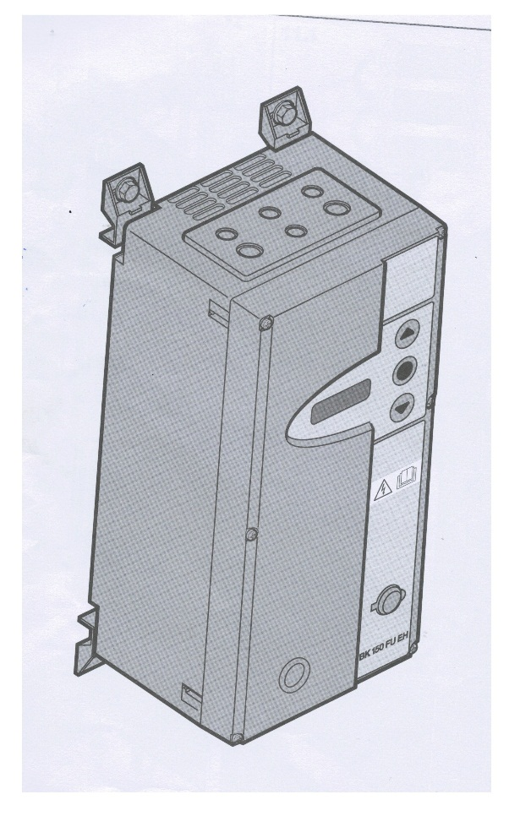
UP BUTTON
DOWN BUTTON
STOP BUTTON
ROUTINE MAINTENANCE

As the owner or operator of the door, you must have the system inspected & maintained by NIHVA/specialist once a year in. In the case of more than 50000 door cycles per year, every 6 months.

DAILY:
- Do visual inspection for mechanical damage to product.
- Ensure proper voltage & all electrical connections are proper before operating.
- Clean the lenses & reflectors regularly with a soft, dry lint-free towel.

EMERGENCY OFF-
In emergency situations, de-energize the control by actuating the main switch, pulling the mains plug or, if available, actuating the red emergency-OFF button.
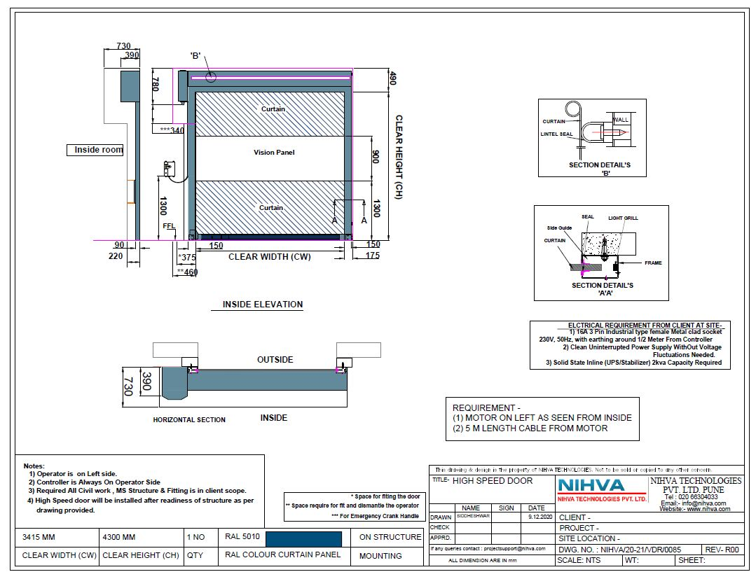
GA DRAWING:

SPARE PARTS-

Sr No | Item
1 | Side assembly bearing side
2 | Side assembly operator side
3 | Shaft
4 | Operator
5 | Brake
6 | Anti-static curtain
7 | Anti-static curtain section
8 | Complete bottom part
9a | Flange bearing
9b | Bearing with groove + bearing shell
10 | Complete emergency opening guide roller
11 | Aluminium wind lock
12 | Wind lock end piece
13 | Cover plug
14a | Seal for guide
14b | Side assembly brush seal
15 | Plastic end piece
16 | Transmission
17a | Left counter weight guide box
17b | Right counter weight guide box
18 | Bowden cable
19 | Radio crash switch
20 | Radio crash receiver
21 | Counter weight sheet
22a | Automatic re-feed left complete
22b | Complete left return guide bush
23a | Automatic re-feed right complete
23b | Complete right return guide brush
24a | Curtain loop complete
24b | Brush seal
25a | Sealing frame channel
25b | Lintel brush Aluminium
26 | Emergency opening Bowden cable handle
27 | Light grille
28a | Light grille support
28b | Light grille support
29 | Cable duct
30 | Keypad
31 | Lockable main switch
32 | Rotary release emergency-off button
33 | Keypad extension
34 | Sealing frame clips



